**Project Design Phase-II**

**Data Flow Diagram & User Stories**

| Date | 26 june 2025 |
| --- | --- |
| Team ID | LTVIP2025TMID33880 |
| Project Name | Transfer Learning-Based Classification Of PoultryDiseases For Enhanced Health Management |
| Maximum Marks | 4 Marks |

**Data Flow Diagrams:**

A Data Flow Diagram (DFD) is a traditional visual representation of the information flows within a system. A neat and clear DFD can depict the right amount of the system requirement graphically. It shows how data enters and leaves the system, what changes the information, and where data is stored.



**Example:** [**(Simplified)**](https://developer.ibm.com/patterns/visualize-unstructured-text/)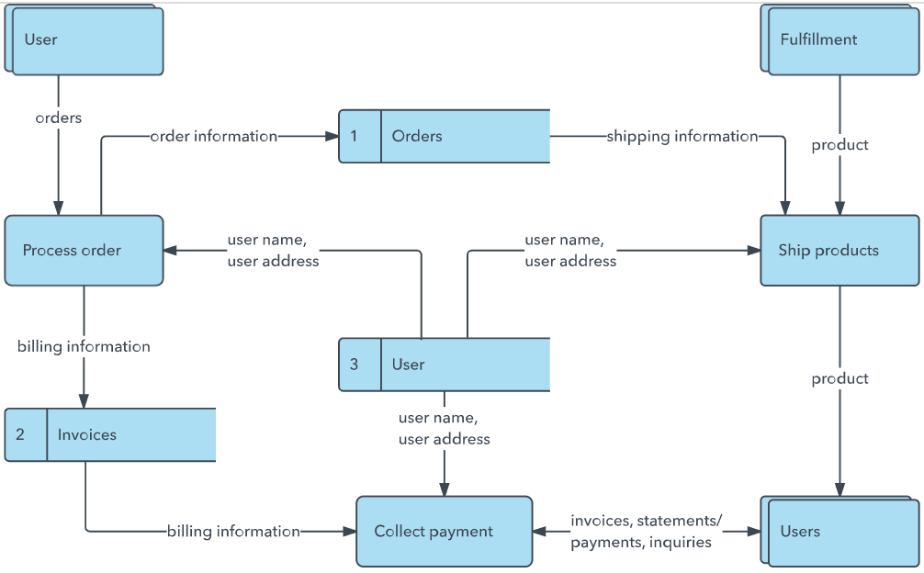

**User Stories**

Use the below template to list all the user stories for the product.

| **User Type** | **Functional Requirement (Epic)** | **User Story Number** | **User Story / Task** | **Acceptance criteria** | **Priority** | **Release** |
| --- | --- | --- | --- | --- | --- | --- |
| Customer (Mobile user) | Registration | USN-1 | As a user, I can register for the application by entering my email, password, and confirming my password. | I can access my account / dashboard | High | Sprint-1 |
| Customer (Mobile user | Registration | USN-2 | As a user, I will receive confirmation email once I have registered for the application | I can receive confirmation email & click confirm | High | Sprint-1 |
| Customer (Mobile user | Registration | USN-3 | As a user, I can register for the application through Facebook | I can register & access the dashboard with Facebook Login | Low | Sprint-2 |
| Customer (Mobile user | Registration | USN-4 | As a user, I can register for the application through Gmail | I can access dashboard after Gmail authentication | Medium | Sprint-1 |
| Customer (Mobile user | Login | USN-5 | As a user, I can log into the application by entering email & password | I can securely access my account with login credentials | High | Sprint-1 |
| Customer (Mobile user | Dashboard detecion | USN-6 | As a user, I can upload poultry images and get the disease classification result. | get accurate prediction and confidence score High | High | Sprint-2 |
| Customer (Web user) | Dashboard | USN-7 | As a user, I can view a dashboard showing disease history and trends. | I can view history, graphs, and summaries of disease detections | Medium | Sprint-3 |
| Customer Care Executive | Feedback management | USN-8 | As an executive, I can review user feedback and flag incorrect classifications. | I can view flagged entries and send them to admin for review | Medium | Sprint-3 |
| Administrator | Model update | USN-9 | As an admin, I can retrain the model using newly collected images and feedback. | Updated model improves classification accuracy | High | Sprint-3 |
| Administrator | User management | USN-10 | As an admin, I can manage user accounts, reset passwords, and control access. | I can activate/deactivate accounts and perform admin actions | Medium |  |
|  |  |  |  |  |  |  |
| Poltry farmer (mobile) | User registration | USN-1 | As a user, I can register by providing name, mobile number, email, and password. | Successful registration redirects me to the home screen. | High | Sprint-1 |